Denver Lions Foundation Annual Report
Fiscal Year 2024–2025
Presented to: The Denver Lions Club
Date: October, 14 2025
Prepared by: The Denver Lions Foundation Board
This annual report summarizes the activities, financial performance, and community impact of the Denver Lions Foundation during the 2024–2025 fiscal year. It also outlines the Foundation’s goals and direction for the coming year, reflecting our continued commitment to transparency, accountability, and service to others.

Denver Lions Foundation Annual Report 2024–2025
The Denver Lions Foundation is a Colorado nonprofit corporation that serves as the philanthropic arm of the Denver Lions Club. All members of the Denver Lions Club in good standing are members of the Foundation. The Foundation is recognized as a tax-exempt organization under Section 501(c)(3) of the Internal Revenue Code.
Mission and Purpose
The Foundation supports a wide range of charitable activities benefiting both local and international communities. These efforts are funded through voluntary contributions from Club members and other donors, income generated from the Endowment Fund, and grants from partner organizations.
Recovery and Strengthening Measures
During the 2024–2025 Lions fiscal year, the Foundation remained in recovery mode following the discovery of an embezzlement that occurred over several years, as detailed in the 2023–2024 report. In response, significant steps were taken to strengthen financial oversight and governance, ensuring the integrity of all future operations:
- Engaged an independent bookkeeping firm to oversee all financial activities
- Increased the Foundation’s crime insurance policy
- Implemented full board review of all issued checks
- Required two authorized signatures on any check over $1,000
Despite the challenges posed by this incident, the Foundation continued to perform strongly, achieving meaningful community impact and prudent financial growth.
Financial Highlights (FY 2024–2025)
- Donations: Over $7,100 from Denver Lions Club members and other contributors
- Endowment Growth: 10.7% increase, bringing the total to $2,994,076
Program Funding Overview
The Foundation provided $120,922 in total funding during the fiscal year, distributed across its four core pillars:
Pillar | Amount Funded
Sight | $25,540
Hearing | $5,769
Social | $5,764
Youth | $83,849

Funding Highlights
- *$50,000 to Savio House for the Bluestem Project and construction of a new state-of-the-art playground
- $2,500 for groceries to support 8 families at Thanksgiving
- $2,400 in support of international missions
- $21,000 for 168 eyeglass vouchers ($125 each) for individuals in need
- $1,700 for two eye surgeries through RMLEB, matched by $6,700 from RMLEB
- $1,000 grant to the Colorado Lions Camp
- $5,800 to provide hearing tests for 38 individuals at the Marion Downs Center

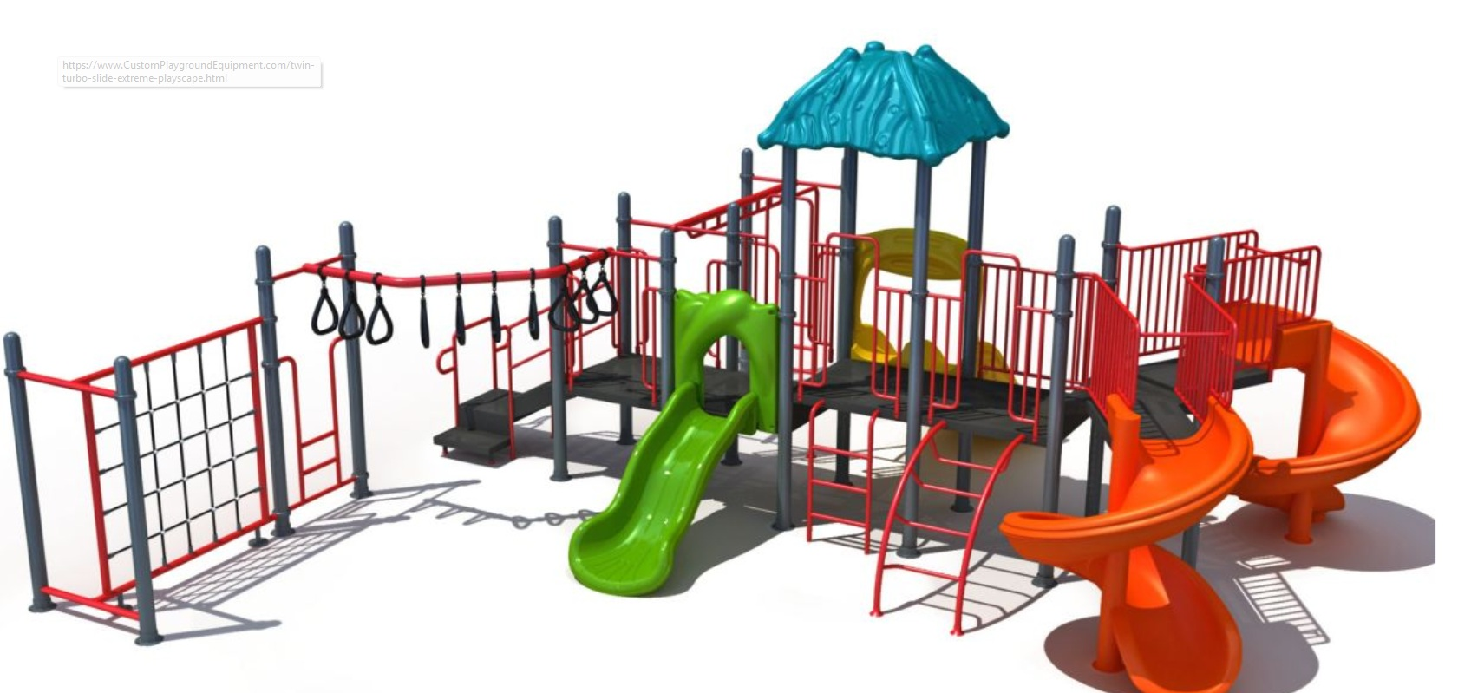
*Savio’s newest program, Bluestem, is under construction in Lakewood. This will be the first program in the nation that lets entire families live together safely while parents recover from substance use. Instead of being separated, parents and children will live in individual townhomes on one campus, surrounded by support. This approach gives families a chance to heal together and helps children avoid the trauma of being removed when it’s not necessary.

With the support of the Denver Lions Foundation, the site will include a playground where children can feel safe, be outside, and just be kids. It will have a rubber mulch surface and equipment designed for young children.

The Foundation extends its sincere thanks to the leaders of each pillar for their dedication and guidance throughout the year:
- Sight: Arti Kale
- Hearing: Sally Hooks
- Social: John Love
- Youth: Dottie Lynn

Denver Lions Early Learning Center (Rude Park) Update
During the 2024–2025 fiscal year, following the results of the developer RFP and recommendations from the Urban Land Conservancy (ULC), the Denver Lions Foundation agreed to select Evergreen Realty Group as the developer for the Rude Park property. This decision was based on input from Lions members who participated in the developer review meeting and on findings from a membership survey.
The Foundation has signed a Letter of Intent (LOI) with Evergreen Realty Group to begin negotiations for the sale of the land and building located at 1275 Decatur Street, Denver, CO 80204—the longtime home of the Denver Lions Early Learning Center (Rude Park) for more than 65 years. The agreed purchase price is $3,000,000, all of which will go to the Denver Lions Foundation.
Closure of this agreement was contingent on Evergreen securing the Middle-Income Housing Tax Credit (MIHTC), which has now been awarded. Evergreen has also submitted its Notice of Election to Exercise Option, formally committing to the purchase.
The site will be redeveloped under the name Park Place. The project will feature 80 thoughtfully designed residential units serving households earning between 80% and 120% of Area Median Income (AMI). Located along a high-capacity transit corridor in Denver’s Sun Valley neighborhood, this Transit-Oriented Development will provide residents with convenient regional access—from Jefferson County to Aurora—right from their front door. More than just new housing, Park Place will help transform a vital community site, providing stability, opportunity, and long-term affordability for families in a growing and changing area.
Mile High Early Learning, which currently operates the Rude Park Early Learning Center, plans to close the facility by June 2026. The organization is assisting children and families in transitioning to the Blossom House Early Learning Center—Mile High’s newest facility, which is currently in the process of opening.

Once the sale is finalized, the Foundation will have an increased funding capacity with a strong emphasis on early childhood education (ECE). Specific ECE plans for the use of these funds will be developed closer to the closing date.

Endowment Update:
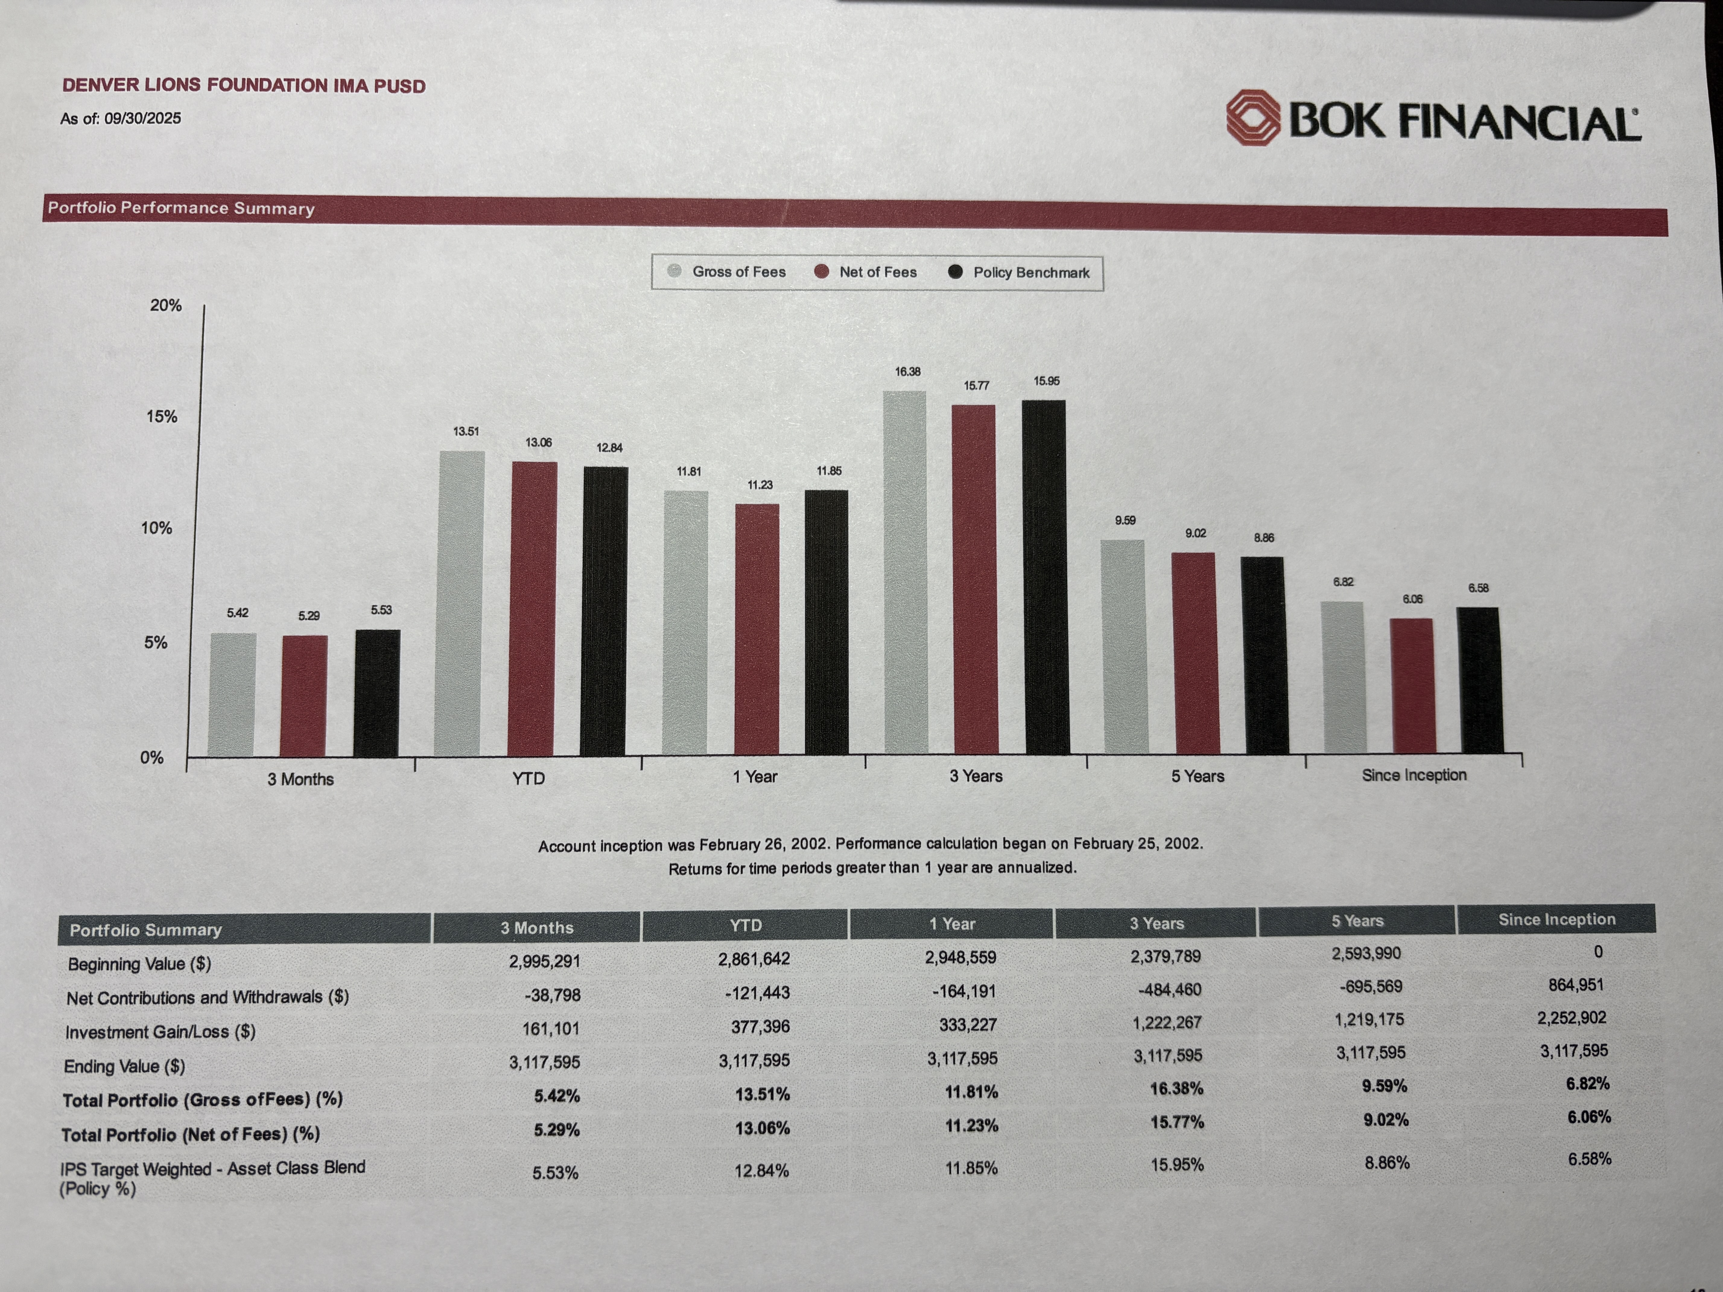
The Foundation’s endowment account is being managed through BOK Financial with a diverse portfolio that can be supplied for review by Club members upon request to the Foundation President. In summary, the account currently stands at $3,117,595. In the past twelve months there were $164,191 in withdrawals and a $333,227 increase from investment gains. See below for additional information on the performance.

Looking Ahead
The 2024–2025 year was one of rebuilding, reflection, and renewed purpose. Through careful oversight, transparency, and dedication, the Denver Lions Foundation has emerged stronger and more resilient.
As we look ahead to the 2025–2026 fiscal year, our focus will shift from recovery to growth — strengthening donor confidence, re-engaging past funding partners, and expanding our impact in the Denver community and beyond. With a solid foundation in place and the continued generosity of our members and supporters, we are well-positioned to advance our mission of service, integrity, and compassion in the coming year.

Goals for Fiscal Year 2025–2026
1. Strengthen Support from Denver Lions Club Members
Increase donations from club members by reinforcing confidence in the Foundation’s stability and transparency. We will communicate more consistently with the Club to ensure members clearly understand our financial position and how their contributions are making an impact.
2. Rebuild Relationships with Past Grant Funders
Reconnect with key partners such as the King Foundation and the Schlessman Foundation to restore their confidence in our integrity, accountability, and effectiveness. We will demonstrate the Foundation’s renewed commitment to sound stewardship and measurable community impact.
3. Measure and Communicate Impact
Implement improved tracking systems to measure the outcomes of our funding—especially in areas such as employment, entrepreneurship, and the number of individuals served. Then communicate the outcomes to our club membership and donors on a regular basis.
4. Expand Visibility and Fundraising Opportunities
Enhance the Foundation’s presence on the Colorado Gives Day platform and the Denver Lions web pages to attract new donors and leverage matching funds. By improving our profile and storytelling on these sites, we aim to generate additional community-based support.

The Denver Lions Foundation is grateful for the continued generosity of all members who have contributed so much over the years. We also encourage those who have not yet donated to consider supporting the Foundation with any gift through the Colorado Gives Day or Denver Lions website. Without the dedication and support of our fellow Denver Lions, we would not be able to plan, grow, and continue making a meaningful impact in our community.

